AWS ECS Cluster
Table of Contents
Deploy a Spring Boot application in ECS cluster 1
1) Create a Target Group: 2
1.1) Open Target Group 2
1.2) After adding above configuration click on Next Create Target Group 3
1.3) After creating target group, click on Action Associate with a existing Load Balancer 3
1.4) Select appropriate Load Balancer 4
1.5) Click on Listeners and rules tab Select HTTPS:443 Listener Add Rule 4
1.6) Mention the Rule Name and tags Next 4
1.7) Define the Rule condition 5
1.8) Add the Target Group (TG-dpm-kafka-producer) 5
1.9) Set the Priority 6
2) Deploy/add dpm-producer-service to ECS cluster (br_dpm_ecstest_cluster) 7
2.1) Click on Task Definition under ECS 7
2.2) Define the task name lets it is dpm-kafka-producer-task 7
2.3) Mention the Container name, lets it is dpm-kafka-producer-cnt , select the Image URI 8
2.4) Add Container port 80 and 8080 with HTTP protocol 8
2.5) Add Environment variable, key PROFILE and value is dev 8
2.6) Click on create task 8
3) Service deployment in ECS 9
3.1) Select Cluster br_dpm_ecstest_cluster Create 9
3.2) Select the task name and Revision (Latest) which is already created (dpm-kafka-producer-task) 9
3.3) Give the service name as dpm-kafka-producer-service 9
3.4) Heath check grace period 60 seconds 9
3.5) Select the existing Networking VPC ( vpc-0ab6253086419950d / dev-vpc ) 10
3.6) Select 2 existing Subnets ( subnet-03e74a940e5a92855 and subnet-03b93e0e448e171b2 ), ip start with 10 10
3.7) Select below existing security group name 10
3.8) Turned off IP 10
3.9) Select Use load Balancing ( ics-dpm-dev-ecs-lb ) 11
3.10) Select Container dpm-kafka-producer-cnt 8080:8080 11
3.11) Select existing load balancer ( ics-dpm-dev-ecs-lb ) 11
3.12) Select exiting Listeners HTTPS:443 11
3.13) Use existing Target Group ( TG-dpm-kafka-producer ) 11
4) Invoke the producer service in postman 12

Deploy a Spring Boot application in ECS cluster

Create a Target Group:

Open Target Group
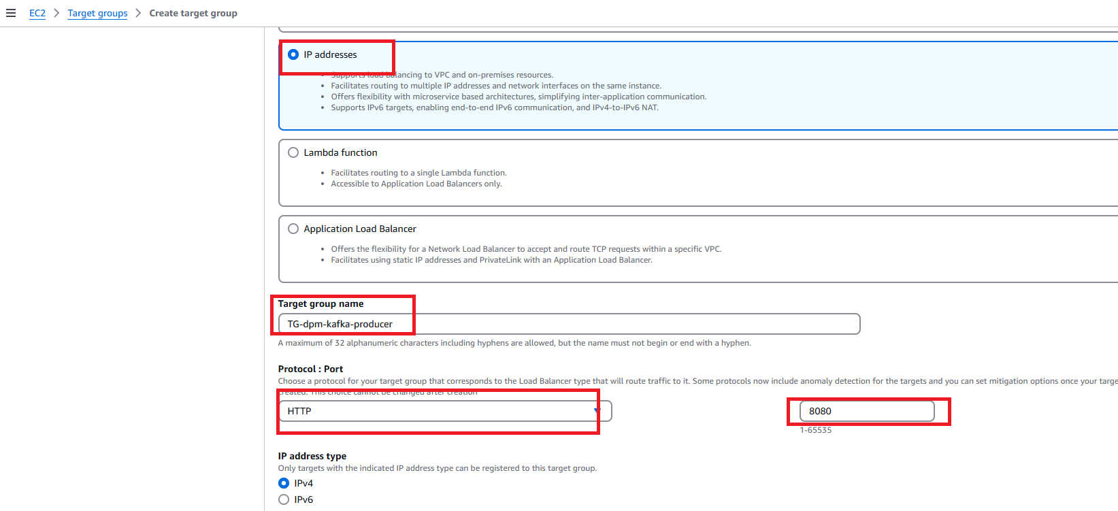
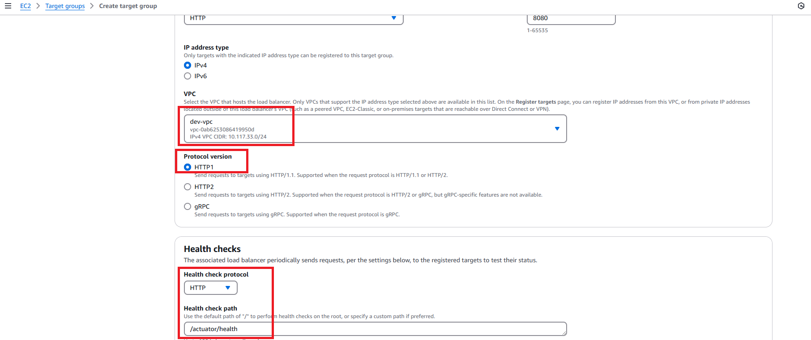
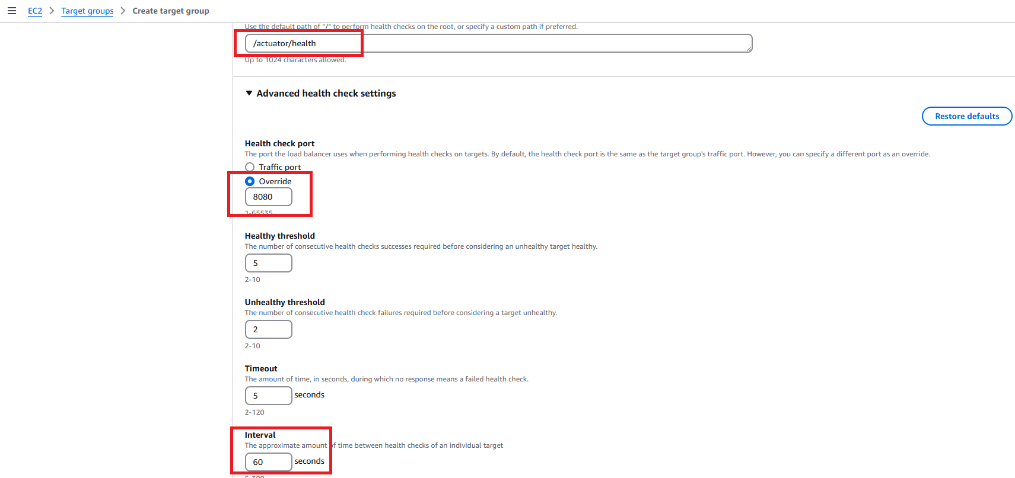

After adding above configuration click on Next Create Target Group

After creating target group, click on Action Associate with a existing Load Balancer

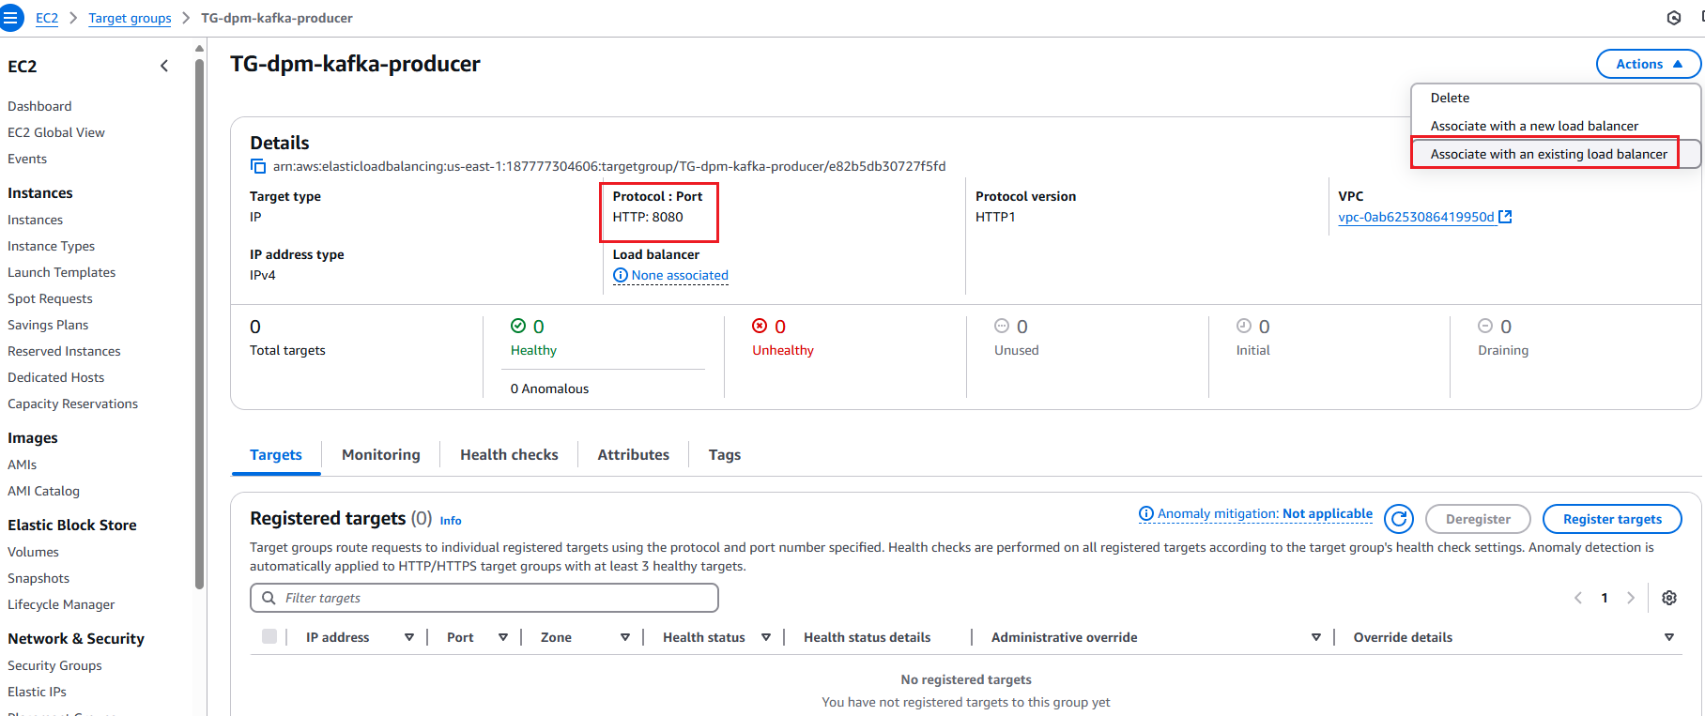

Select appropriate Load Balancer

Click on Listeners and rules tab Select HTTPS:443 Listener Add Rule
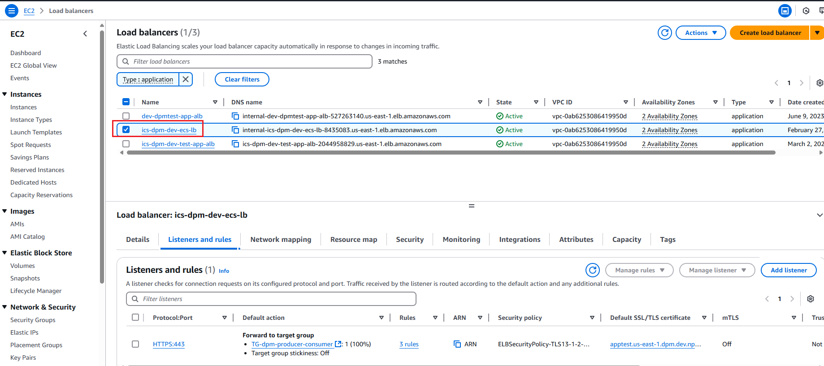

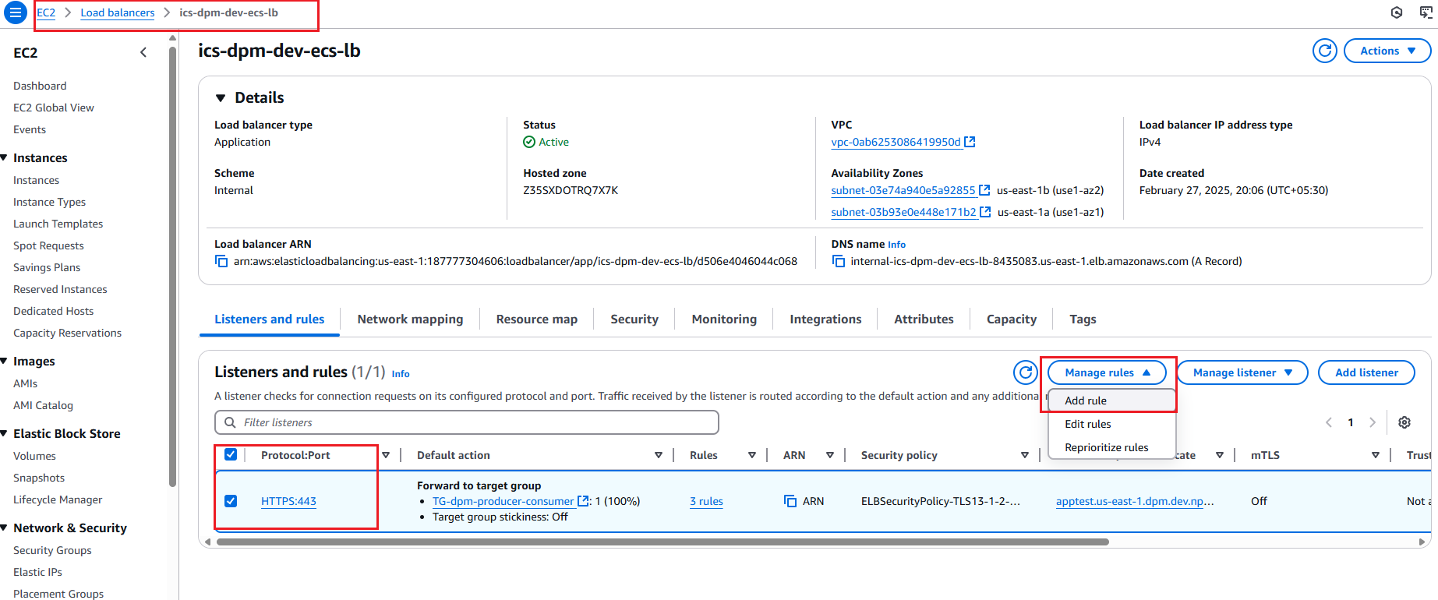

Mention the Rule Name and tags Next

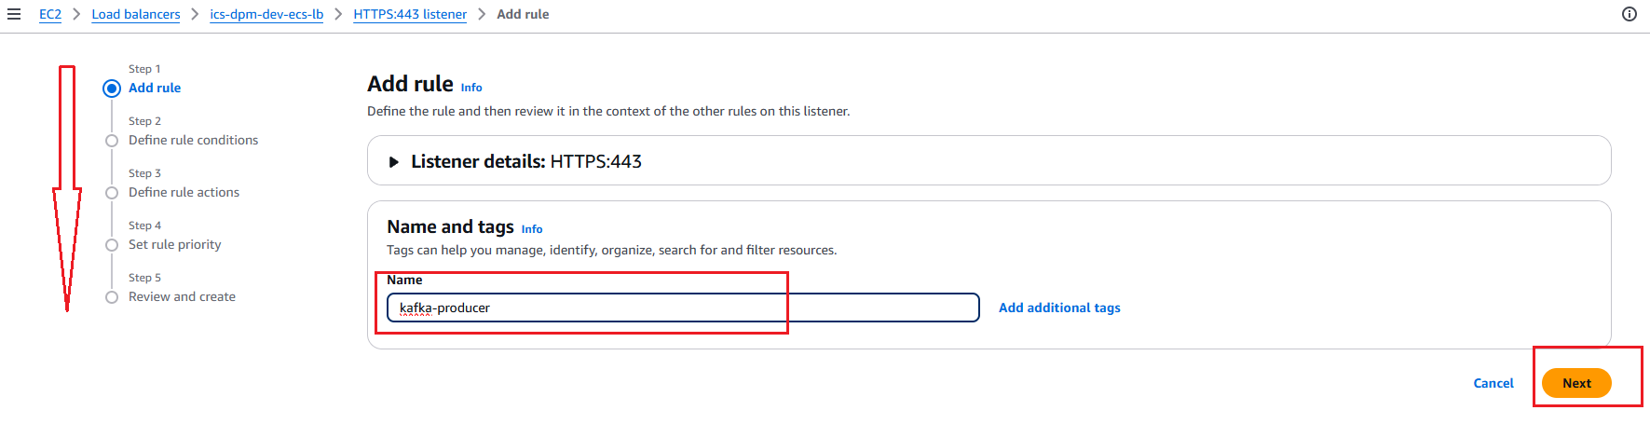

Define the Rule condition
- For producer service path it is /producer/*
- For consumer/order service path it is /consumer/*
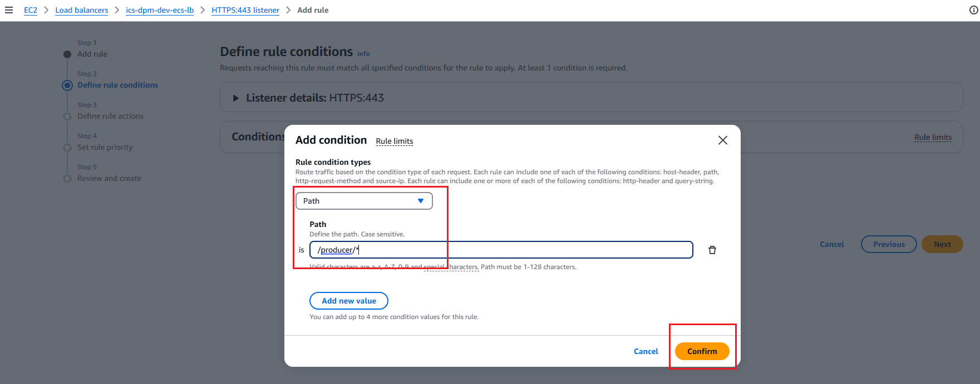

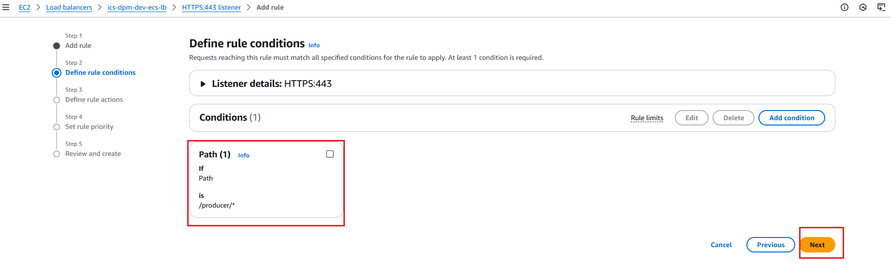

Add the Target Group (TG-dpm-kafka-producer)

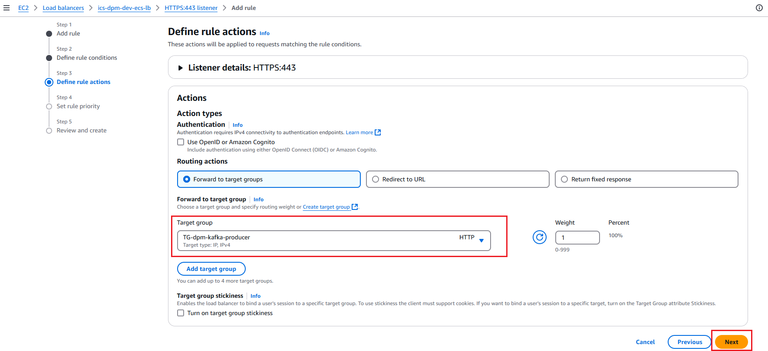

Set the Priority
- For kafka-producer service Priority is 1
- For kafka-consumer/order service Priority is2

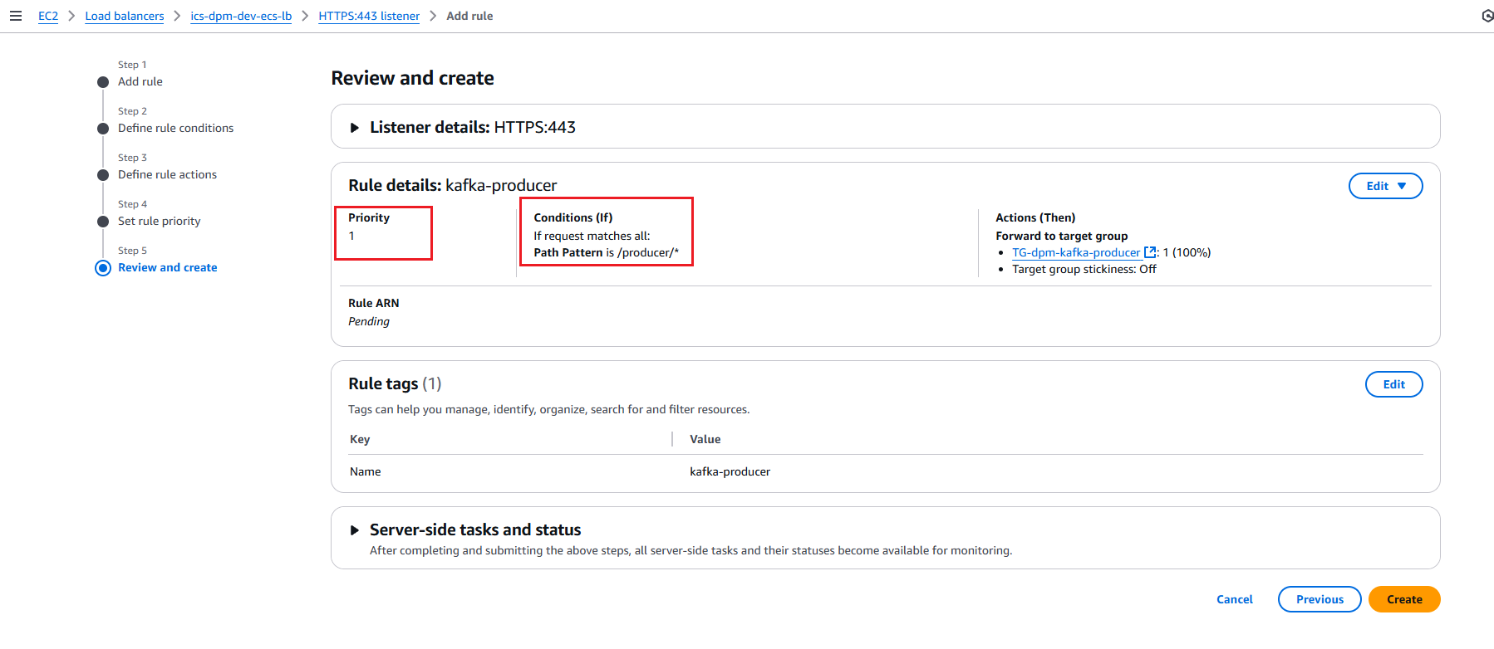

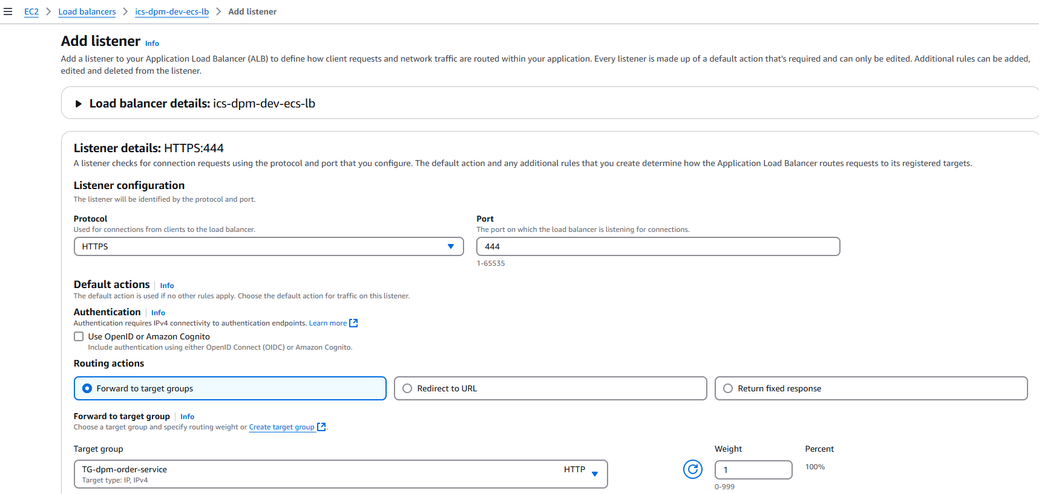

Deploy/add dpm-producer-service to ECS cluster (br_dpm_ecstest_cluster)

Click on Task Definition under ECS

Define the task name lets it is dpm-kafka-producer-task

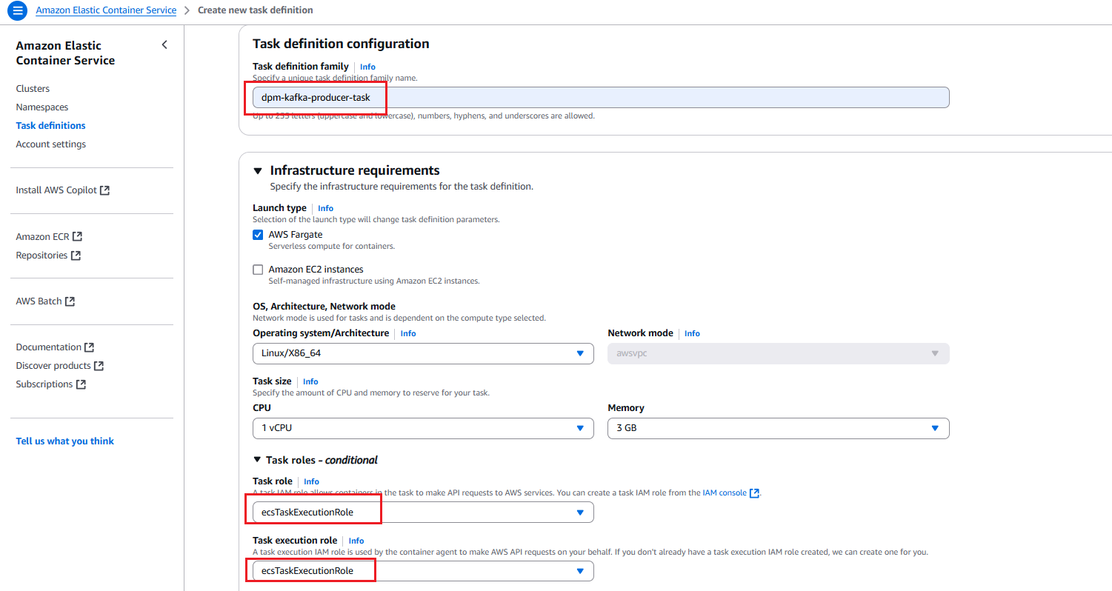

Mention the Container name, lets it is dpm-kafka-producer-cnt , select the Image URI

Add Container port 80 and 8080 with HTTP protocol

Add Environment variable, key PROFILE and value is dev

Click on create task
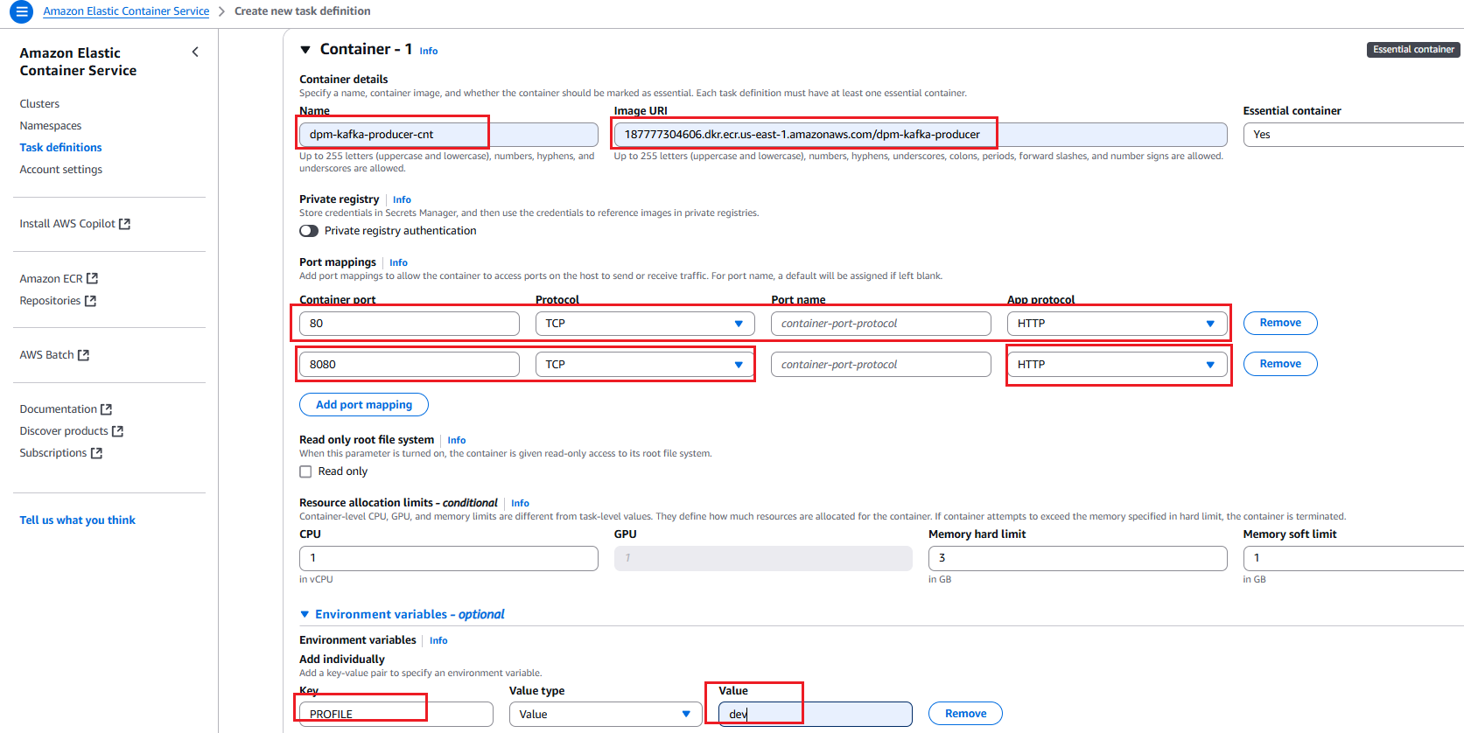

Service deployment in ECS

Select Cluster br_dpm_ecstest_cluster Create

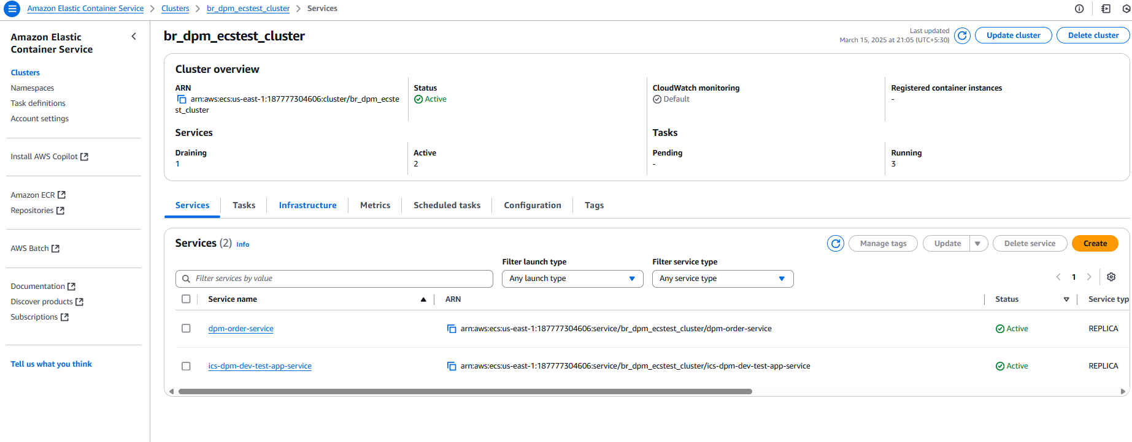
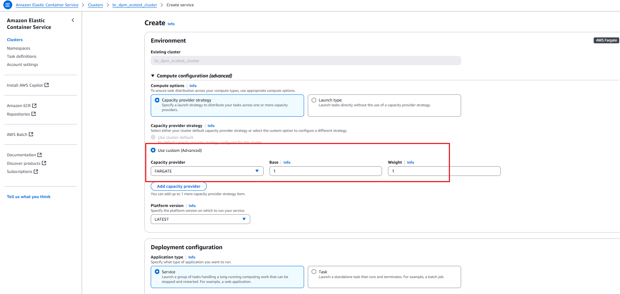

Select the task name and Revision (Latest) which is already created (dpm-kafka-producer-task)

Give the service name as dpm-kafka-producer-service

Heath check grace period 60 seconds

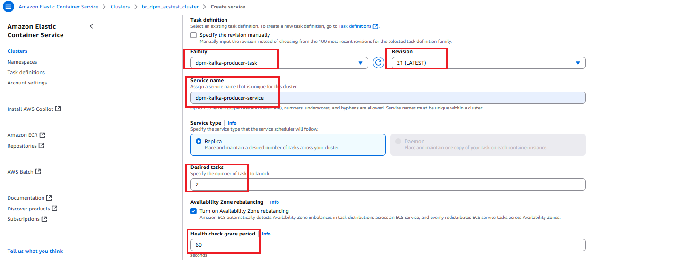

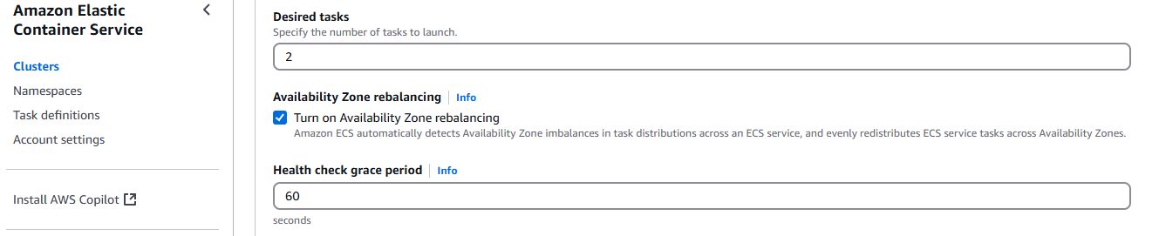

Select the existing Networking VPC ( vpc-0ab6253086419950d / dev-vpc )

Select 2 existing Subnets ( subnet-03e74a940e5a92855 and subnet-03b93e0e448e171b2 ), ip start with 10

Select below existing security group name
sg-083de31d3fae58010 (BR-AWS-Outbound)
sg-0e470f744d0bd8d91 (BR-AWS-Service)
sg-04fdb966f3ccc0a50 (Inbound)
sg-004256f2080f2805d (msk) - for Kafka

Turned off IP

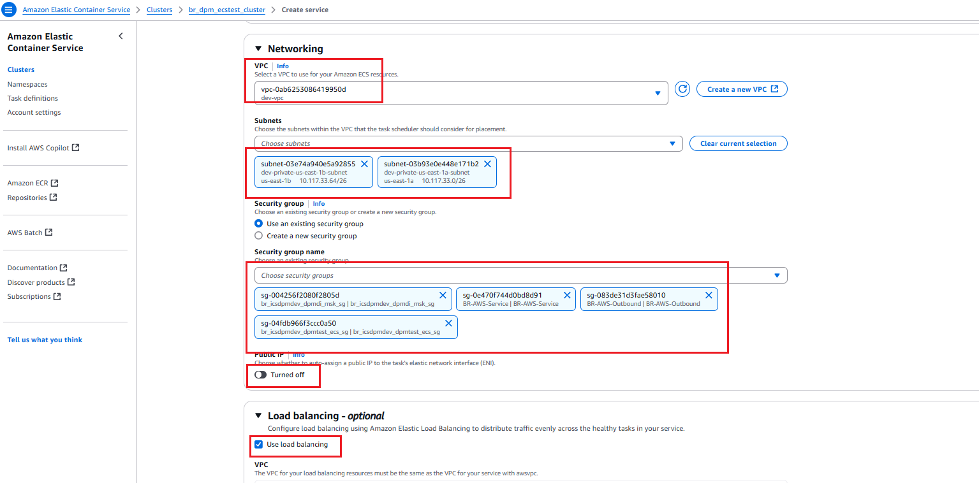

Select Use load Balancing ( ics-dpm-dev-ecs-lb )

Select Container dpm-kafka-producer-cnt 8080:8080

Select existing load balancer ( ics-dpm-dev-ecs-lb )

Select exiting Listeners HTTPS:443

Use existing Target Group ( TG-dpm-kafka-producer )

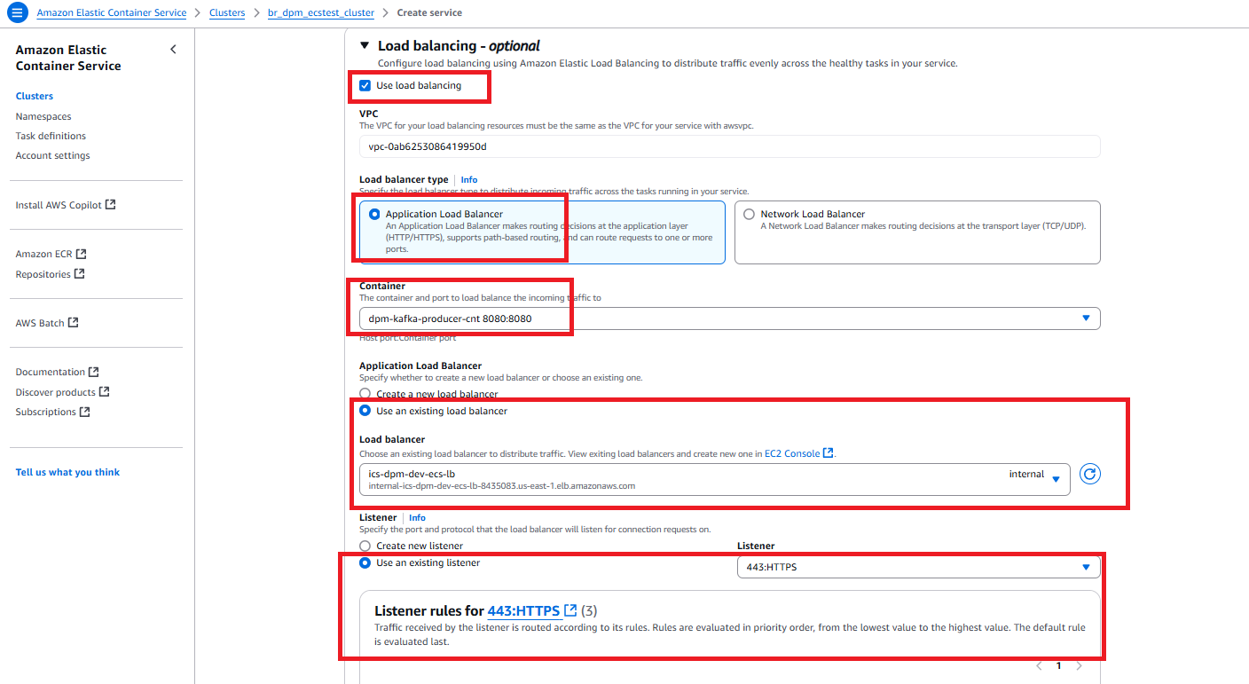
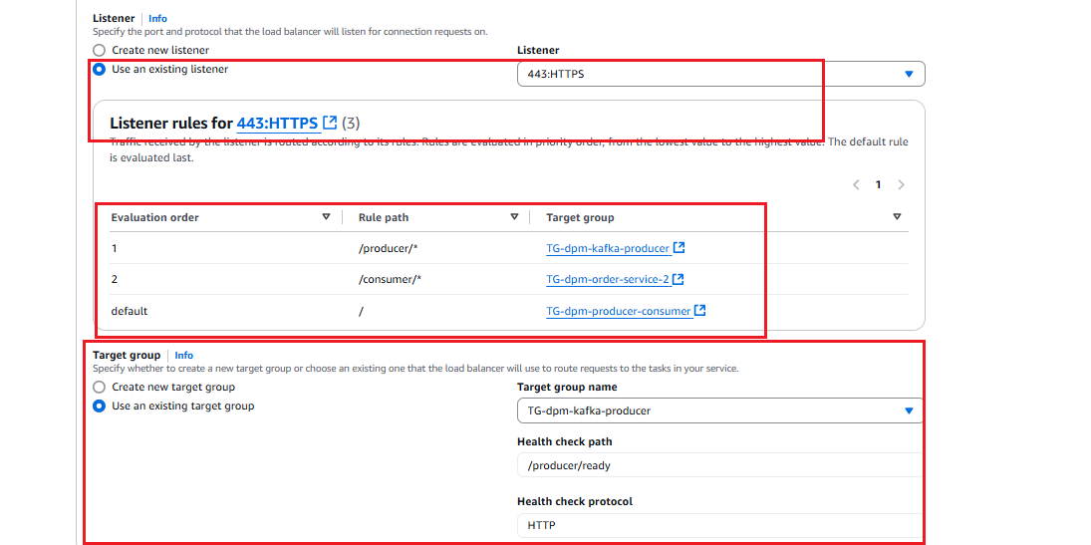

Invoke the producer service in postman
Method Type: Get
https://internal-ics-dpm-dev-ecs-lb-8435083.us-east-1.elb.amazonaws.com/producer/ready
